Project: Woodson Park Academy & YMCA-ELC
Week Ending: July 12th, 2019

THIS WEEK:
- Site contractor’s survey crew onsite – continues
- Erosion control, silt fence and tree save installed
- Landscape Architect marked remaining trees to be posted
- Had pre-install meeting with TA Jones of COA
- COA watershed is installing new 8” water line off of Hollowell with no cost to this project.

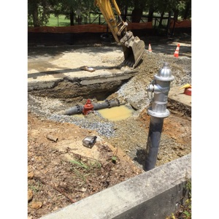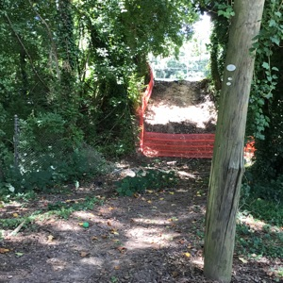

COA install of new water main Tree Save installed

NEXT WEEK – July 15 thru July 19:
- Erosion control per LDP plans
- Install web cam

PAYMENT STATUS:
- Gmp#1 $3,703,488.00
  - Paid to date amount $0.00
- GMP#2 $28,686,295.00
  - Paid to date amount $0.00

SCHEDULED DATE OF SUBSTANTIAL COMPLETION
- WPA – September 17, 2020
- YMCA-ELC - September 14, 2020

PREPARED BY:
- Matt Dauber, Carroll Daniel Construction Co.

